PROJECT REPORT

ON

Dry/wet Garbage Segregation and Monitoring

SUBMITTED BY

Omkar Bhilare

Rishikesh Datey

Neha Ghogre

Under the Guidance of

Mr. Ramgopal Sahu



DEPARTMENT OF ELECTRONICS & TELECOMMUNICATION

P.E.S.MODERN COLLEGE OF ENGINEERING

PUNE – 411 005.



SAVITRIBAI PHULE PUNE UNIVERSITY

Academic Year: 2021-22

**CERTIFICATE**

This is to certify that

**Omkar Bhilare Exam No. T19031013**

**Rishikesh Datey Exam No. T190313023**

**Neha Ghogre Exam No. T190313045**

Of T.E. E&TC have successfully completed the Project titled **‘Dry / Wet Garbage Segregation and Monitoring’** during the academic year 2021-22 for the Course **Mini Project**. This report is submitted as per the requirement prescribed by Savitribai Phule Pune University.

**Dr. Mrs. R. S. Kamathe Mr. Ramgopal Sahu**

**H.O.D. (E&TC) Project Guide**

**ACKNOWLEDGEMENT**

We owe our deep gratitude to our project guide, **Mr Ramgopal Sahu Sir** who took keep interest in our project work and guided us all along, till the completion of our project work by providing all the necessary information for developing a good system.

We are extremely thankful to our head of the department, Electronics **Dr.Mrs. R.S. Kamathe** for providing support and encouragement for our project work.

At last we would like to thank our parents, friends and all those who have helped directly or indirectly towards the completion of our project. The successful completion of this project required a lot of guidance and assistance from many people and we are extremely privileged to have got this all along the completion of our project. All that we have done is only due to such supervision and assistance and we would not forget to thank them.

Omkar Bhilare

Rishikesh Datey

Neha Ghogre

**ABSTRACT**

In past few decennium there is an instant growth in the rate of urbanization and thusthere is a need of sustainable urban development plans. Due to the development process the amount of waste generated every day is extreme so, the workload posed on the municipal corporation is extremely high. An efficient method to segregate the waste easily that has been designed in our project, “ Dry and Wet Waste Segregator and Monitoring System”. As the use of technology is increasing day by day, by taking the advantage of this new age technology we are focusing on managing waste effectively. This project will be helpful in our society at primary level for segregating waste initially it will make the process easy and less time consuming.

**TABLE OF CONTENTS**

Sr. Page No.

1. Introduction 6

2. Literature Survey 8

3. System Specifications 10

4. Block diagram & description 12

5. Hardware System Design 14

6. Software System Design 21

7. Enclosure design and description 21

8. Results and Discussion 22

9. Bill of Material 23

10. Applications & Future modifications 24

11. References 26

12. Data Sheets 27

1. **Introduction**

Today enormous urban communities all throughout the planet are dealing with a typical issue, dealing with the city squander adequately without making city messy. The present waste administration frameworks include an enormous number of workers being selected to go to a specific number of dumpsters this is done each day intermittently. This prompts an exceptionally wasteful and messy framework wherein a few dumpsters will be spilling over certain dumpsters probably won't be even half full.

Wastes like plastic, damped paper and so forth may likewise be oppressed to recycling. In some manners by which, the waste will truly work an asset. By isolating waste into entirely unexpected classes we will carry out measures which will cause compelling asset usage. This is used at individual just as society level. Squander the executives is the one in everything about centre contemplations of contemporary age. As countries round the world region unit creating, their contemplations and obligation regarding a better climate is furthermore expanding. During this task, execute an effective decent waste administration framework.

Presently days in many urban areas there are numerous dustbins which are in awful conditions. The trash in a dustbin is totally flooded off the dustbin. Many individuals are tossing trash on that dustbin which is as of now full or flooded. Because of this messy of trash receptacles contamination is expands which are terrible for the climate. This makes an exceptionally terrible look of the city which is an approach to help to the air contamination and to some destructive illnesses which are effectively spreadable.

Waste management is one of the most crucial problems our country is facing right now. India produces 62 million tonnes of waste each year. When we segregate waste, there is not only a reduction of waste that gets landfilled, it also reduces pollution levels by lowering the percentage of garbage exposed to air and water. Waste management is important because it reduces the effect of pollution on the environment and nature. It can also help reduce or reuse the waste materials that are harmful for the environment such as plastic, glass, Styrofoam, thermocol, etc. and many more.

In today's modern era the big problem at public places, households and domestic places Is grabage disposal. And it is major concern for Mincipal corporations also. And best technique for garbage disposal is making individuals dustbin for wet and dry garbage, So this project is about dry and wet garbage segregation.

1. **Literature Survey**

Waste management is the "generation, prevention, characterization, monitoring, treatment, handling, reuse and residual disposition of solid wastes". Many type of waste exists in our environment which includes solid waste, consisting municipal waste (institutional, residential, commercial), agricultural waste, and special waste (sewage sludge, household hazardous waste, health care). As urban population is rising continuously and their consumption patterns are changing this leads to increase in global concern due to which solid waste management has become an issue. So for easy disposal of waste, sorting of waste on the basis of its category is very important. Waste sorting is the method by which waste is separated into different elements. Waste sorting can be done

manually at household level as well as commercial level and collected through curbside collection schemes, or can be separated automatically in materials recovery facilities or mechanical biological treatment systems. [1]

The author describes that the application of smart bin in the managing of the waste collection system of an entire city. As the world is in a stage of up gradation, there is one stinking problem . we have to deal with. Garbage! In our daily life, we see the pictures of garbage bins being overfull and all the garbage spills out. This leads to the number of diseases as large number of insects and mosquitoes breed on it. A big challenge in the urban cities is solid waste management not only in India but for most of the countries in the world. Hence, such a system has to be build which can eradicate this problem or at least reduce it to the minimum level. The project gives us one of the most efficient ways to keep our environment clean and green. [2]

It describes an India about an automatic waste segregating system which is chip and easy to used, solution for segregating the waste at household level. Rapid increase in population has led to improper waste management in metro cities and urban areas which has resulted in spreading of diseases. It is estimated that 2.02 billion tones of municipal solid waste was generated universally in 2006. The segregation, transport, handling and disposal of waste must be managed properly to minimize the risks to the public, and the environment. [3]

It suggested that smart bin is built on microcontroller based platform; waste management has been a crucial issue to be considering this paper is way to achieve good cost. Dustbin is a common and a basic need everywhere. It is observed that often the garbage get accumulated due to irregular removal of garbage present in the dustbin. Here we have figured out a new model for the municipal dustbins which intimates the centre of municipality for immediate cleaning of dustbin. This dustbin is also designed to compress the garbage periodically thus preventing the unnecessary occupying of dustbin’s space by light weighted but space occupying garbage particles like sponges, etc. A leaf switch is pressed by the garbage when it reaches a particular level and an Arduino Uno is programmed in such a way that when the garbage reaches this particular level, intimation is given to the central hub in the form of glowing of LED. “Smart dustbin” (International Journal for Research in Applied Science & Engineering Technology) by “Twinkle singha, K Mukesh kumar” (April 2018). “Smart dustbin” (International Journal for Research in Applied Science & Engineering Technology) by “Twinkle singha, K Mukesh kumar” (April 2018).[4]

1. **Specifications**

**Electrical**

1. IR sensor
   1. Distance Measuring Range:-2 cm to 30 cm
   2. Detect Time:- Upto 2 sec
2. Ultrasonic Sensor
   1. Sensing Range:-40 cm to 300 cm
3. Servo motor
   1. Rotation:- 0 degree to 90 degree
   2. Rotate time:-3 sec
4. Buzzer
   1. Operating Voltage Range:- 3 to 24 Dc

**Mechanical**

1. Foam Sheet Box:- 40x27cm
2. Aluminium Foil Coated Tilt Foam Sheet :-25cm
3. Weight of project:- 2kg
4. **Block diagram & description**

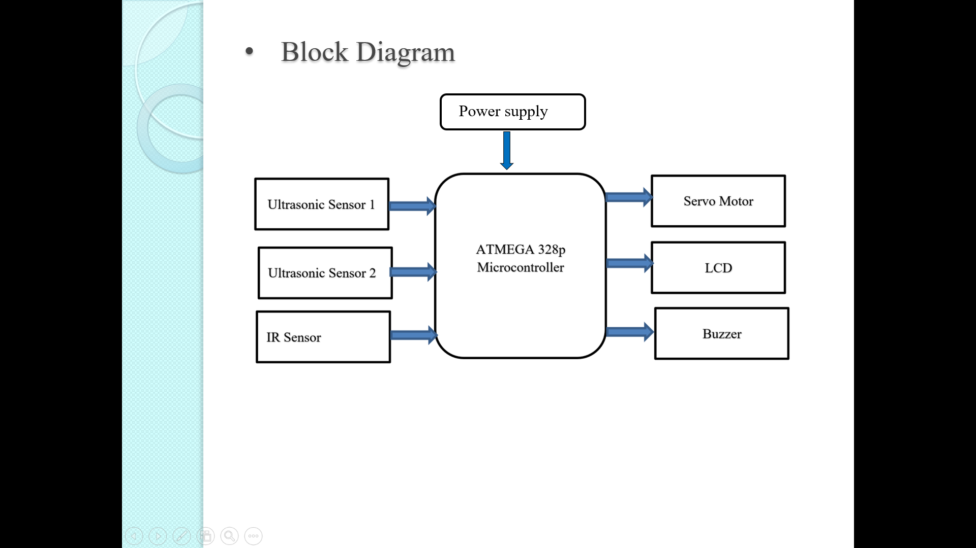

Fig 1.1 (Dry/wet Garbage Segragation and Monitoring)

1.IR sensor: The principle of an IR sensor working as an Object Detection Sensor. When the IR transmitter emits radiation, it reaches the object and some of the radiation reflects back to the IR receiver.

2. Ultrasonic sensor: An ultrasonic sensor is associated with the front side of the junk container. The junk level inside the waste repository is continually checked by a ultrasonic sensor set up inside the garbage bin.

3. Atmega 328P Microcontroller: ATMEGA 328P is high performance, low power controller from Microchip. ATMEGA328P is an 8-bit microcontroller based on AVR RISC architecture.

4. Servo Motor: Servo Motor is use to rotate the plate between box.

5. LCD Display: Here we use 16X2 LCD Display.

6. Buzzer: Buzzer will alert us when dustbin is full

1. **Hardware System Design**

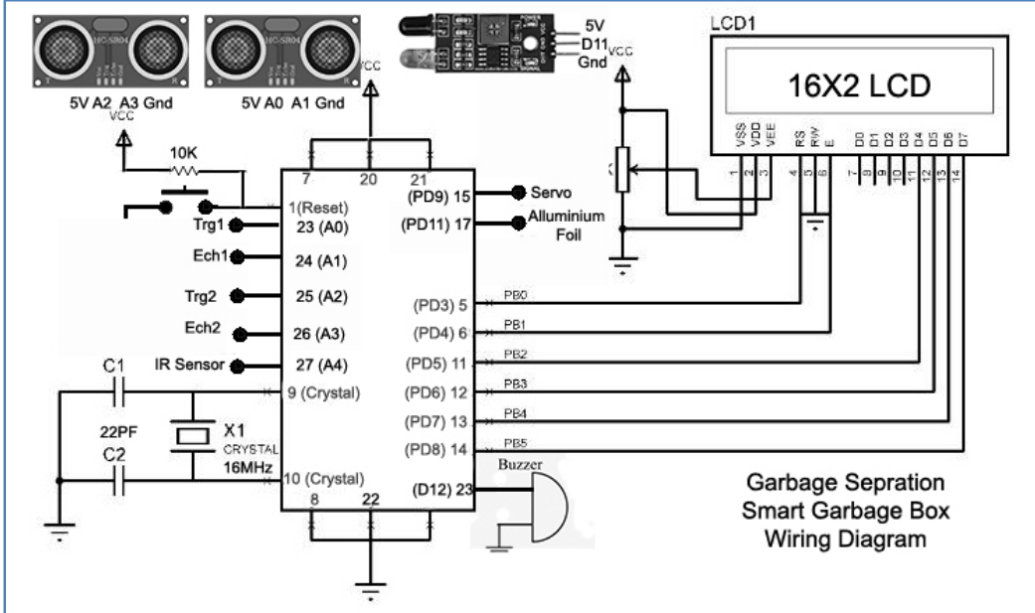

Fig. 1.2 Circuit Daigram

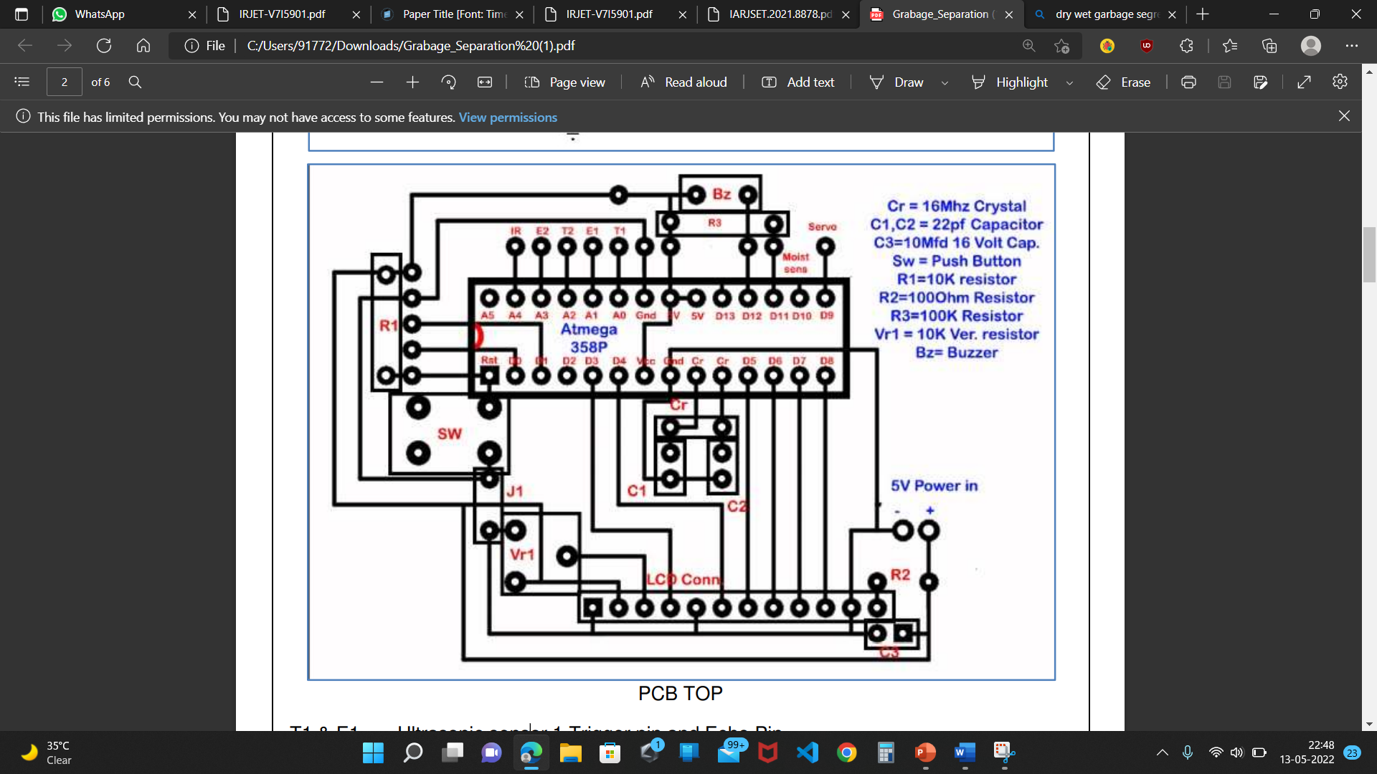

Fig.1.3 PCB Design

T1 & E1 = Ultrasonic sensor 1 Trigger pin and Echo Pin

T2 & E2 = Ultrasonic sensor 2 Trigger pin and Echo Pin

Ir = Ir Sensor signal Pin

Servo = to servo motor

Moist Sensor = to moisture sensor (Aluminium foil)

**5.1 Atmega 328P Microcontroller**

ATmega328 is an Advanced Virtual RISC (AVR) microcontroller. It supports 8-bit data processing. ATmega-328 has 32KB internal flash memory.

ATmega328 has 1KB Electrically Erasable Programmable Read-Only Memory (EEPROM). This property shows if the electric supply supplied to the micro-controller is removed, even then it can store the data and can provide results after providing it with the electric supply. Moreover, ATmega-328 has 2KB Static Random Access Memory (SRAM). Other characteristics will be explained later. ATmega 328 has several different features which make it the most popular device in today’s market. These features consist of advanced RISC architecture, good performance, low power consumption, real timer counter having separate oscillator, 6 PWM pins, programmable Seral USART, programming lock for software security, throughput up to 20 MIPS etc. Further details about ATmega 328 will be given later in this section.

* **ATmega328**is an 8-bit, 28-Pin AVR Microcontroller, manufactured by Microchip, follows RISC Architecture and has a flash-type program memory of 32KB.
* Atmega328 is the microcontroller, used in basic Arduino boards i.e Arduino UNO, Arduino Pro Mini and Arduino Nano.
* It has an **EEPROM** memory of 1KB and its **SRAM** memory is 2KB.
* It has 8 Pins for ADC operations, which all combine to form PortA ( PA0 – PA7 ).
* It also has 3 built-in Timers, two of them are 8 Bit timers while the third one is 16-Bit Timer.
* You must have heard of Arduino UNO, UNO is based on atmega328 Microcontroller. It’s UNO’s heart.
* It operates ranging from 3.3V to 5.5V but normally we use 5V as a standard.
* Its excellent features include cost-efficiency, low power dissipation, programming lock for security purposes, real timer counter with separate oscillator.

It’s normally used in Embedded Systems applications. You should have a look at these Real Life Examples of Embedded Systems, we can design all of them using this Microcontroller.

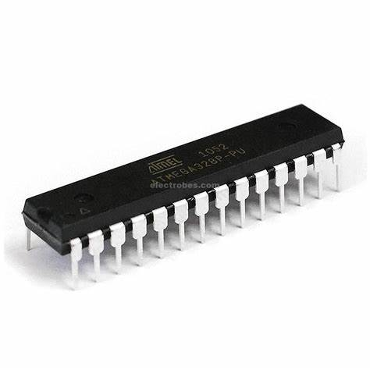

Fig. 1.4 Atmega 328P Microcontroller

**5.2 IR sensor**

Consisting of three pins, a potentiometer, and two LEDs, the IR sensor is an electronic device that emits radiations in order to get a sense of the surrounding. IR sensor has the capability to measure the heat of the object and can also detect motion. Such types of sensors that get the sense of the surrounding by only detecting/receiving or absorbing IR radiations rather than emitting IR radiations are passive IR sensors.

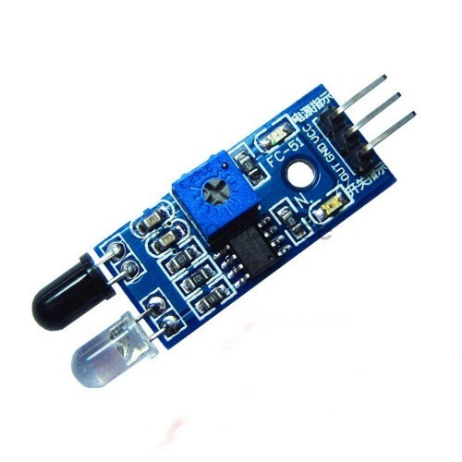

Fig. 1.5 IR sensor

**5.3 Ultrasonic sensor**

As the name indicates, ultrasonic sensors measure distance by using ultrasonic waves.The sensor head emits an ultrasonic wave and receives the wave reflected back from the target. Ultrasonic Sensors measure the distance to the target by measuring the time between the emission and reception. An ultrasonic sensor is associated with the front side of the junk container. The junk level inside the waste repository is continually checked by a ultrasonic sensor set up inside the garbage bin.

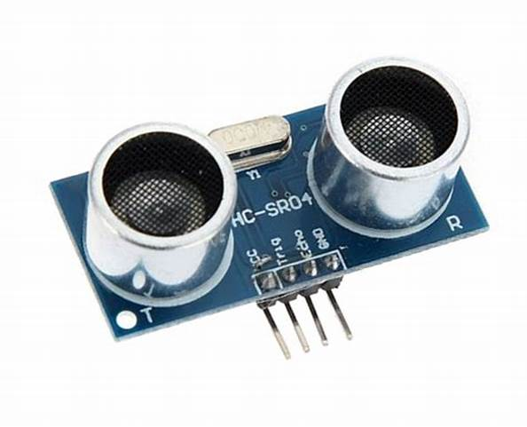

Fig. 1.6 Ultrasonic sensor

**5.4 Servo Motor**

Servo motors (or servos) are self-contained electric devices (see Figure 1 below) that rotate or push parts of a machine with great precision. Servos are found in many places: from toys to home electronics to cars and airplanes. If you have a radio-controlled model car, airplane, or helicopter, you are using at least a few servos. Servo Motor is use to rotate the plate between box.

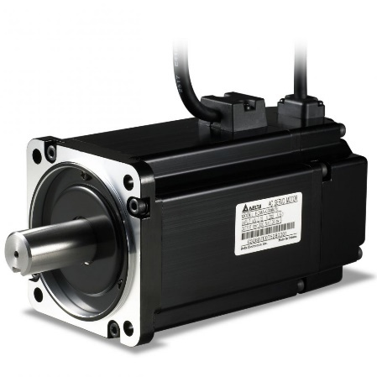

Fig. 1.7 Servvo Motor

**5.5 16x2 LCD Display**

LCD modules are very commonly used in most embedded projects, the reason being its cheap price, availability and programmer friendly. Most of us would have come across these displays in our day to day life, either at PCO’s or calculators. The appearance and the pinouts have already been visualized above now let us get a bit technical. 16×2 LCD is named so because; it has 16 Columns and 2 Rows

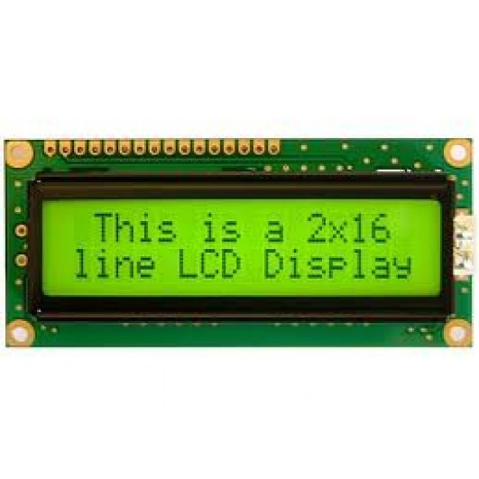

Fig. 1.8 LCD Display

**5.6 Buzzer**

Buzzer Features and Specifications:

Rated Voltage: 6V DC.

Operating Voltage: 4-8V DC.

Rated current: <30mA.

Sound Type: Continuous Beep.

Resonant Frequency: ~2300 Hz.

Small and neat sealed package

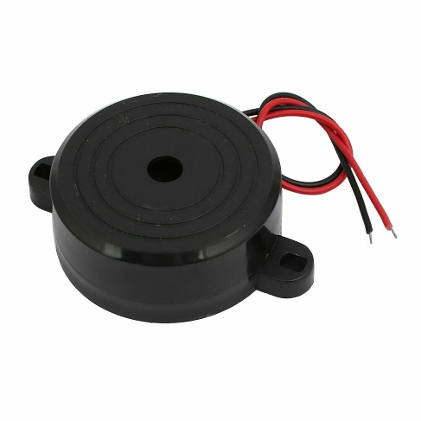

Fig. 1.9 Buzzer

1. **Software Design (Flowchart or Algorithm)**



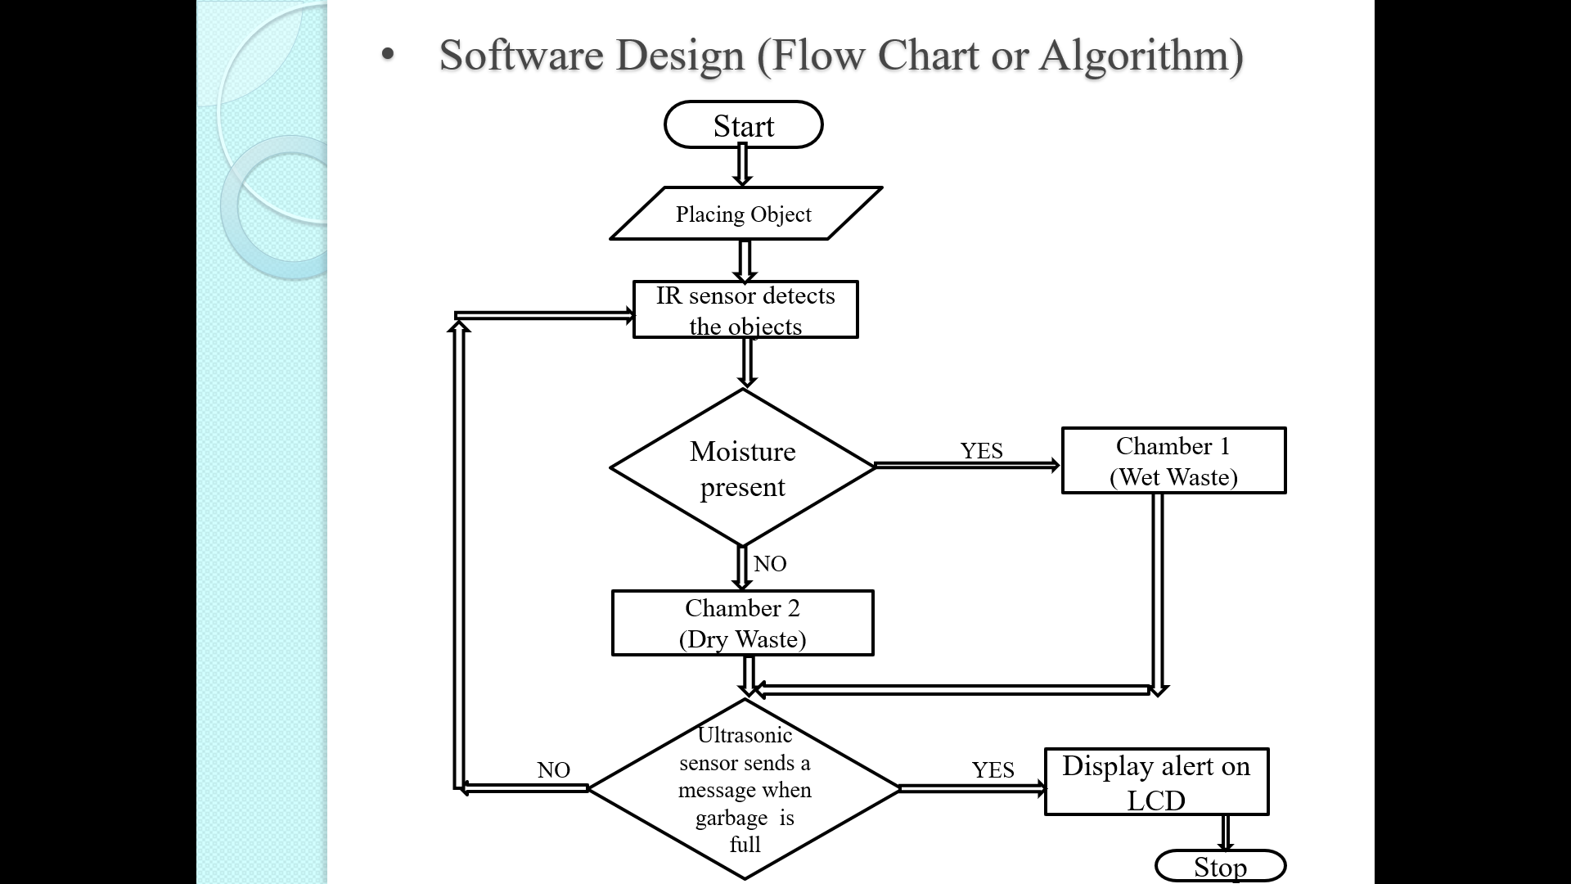

Fig. 1.10 Flowchart of Dry/wet Garbage Segragation and Monitoring

1. **Result (Photo / Audio-Visual / Video Results)**

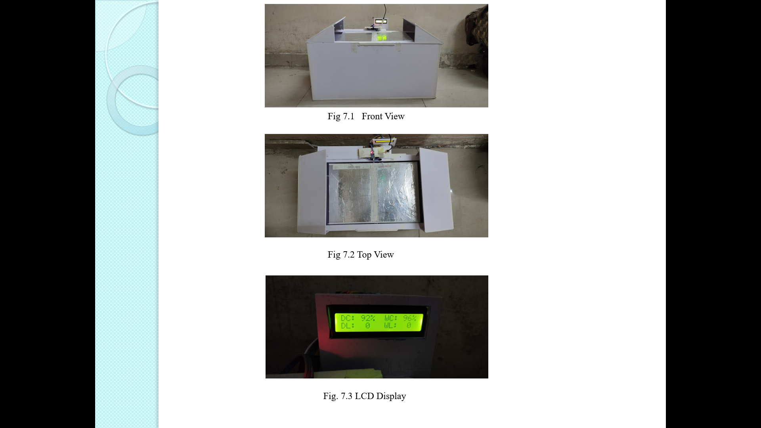

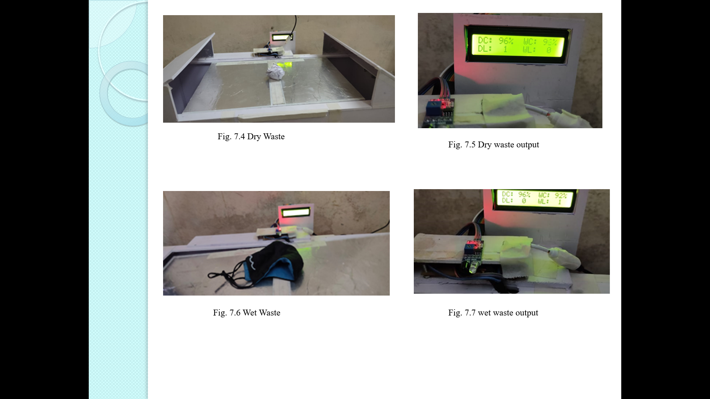

1. **Bill of Material**

|  |  |  |  |  |
| --- | --- | --- | --- | --- |
| **Sr.No** | **Component name , Model Name and Specification** | **Quantity** | **Rate/ Item (Rs.)** | **Total Cost(Rs.)** |
| 1 | Atmega 328P Microcontroller | 1 | 1000  /- | 1000/- |
| 2 | IR sensor | 1 | 265/- | 265/- |
| 3 | Ultrasonic sensor | 2 | 250/- | 500/- |
| 4 | Servo Motor | 1 | 248/- | 248/- |
| 5 | 16X2 LCD Display | 1 | 301/- | 301/- |
| 6 | Buzzer | 1 | 100/- | 100/- |
|  |  |  | **Total Amount (Rs.)** | 2414/- |

1. **Applications& Future modifications**

**9.1 Applications**

* It can be used for collecting the garbage from public palces, household, etc
* Reducing human time and effort which requires to segregate garbage.
* Municipal Corporation can use it as replacement to the traditional dustbins.

**9.2 Future modifications**

The Automatic Waste Segregator has been implemented for the segregation of waste into dry ,wet waste. Further the self-charging technology can be implemented so that the battery of the smart bin is low on power then using solar tracker.

The waste segregator can be improvised to include the separation of paper and plastic, safe segregation of biomedical waste generated at home, compact and aesthetic Mechanical design.

1. **Conclusion**

As a conclusion to thus project the proposed system would be able to monitor the solid waste collection process and management ofthe overall collection process.This projectis very effective in managing waste in any big city rather than segregating the garbage using old segregation methods that is manually. With help of this project the dustbin overflow problems will be resolved which makes the surrounding neat, clean and hygienic. The proposed system is the most efficient way to collect and segregate the garbage

**10.References**

[1]. Ravena singh “Design and development of smart waste subsystem” Centre for Development of Advanced Computing, Mohali (2015)

[2]. Narayan sharma, Nirman singha ” Smart bin implementation for smart cities” (International Journal of Scientific & Engineering Research) in Apirl 2015.

[3] Amruta chandramohanet “Automatic waste segregation system” (National Conference on Communication and Image processing) in April 2017.

[4] Twinkle singha, K Mukesh kumar “Smart dustbin” (International Journal for Research in Applied Science & Engineering Technology) in April 2018.

**11.Data Sheets :**

**11.1 ATmega328P Microcontroller**

1 Introduction

This document is a short introduction to the architecture of the Atmel ATmega328P microcontroller and provides some information on using it in EE 459 projects. Additional documents on the EE 459 web site describe using the C software development system. For more complete information on any of the topics below, see the full Atmel datasheet or programming manual. A portion of the data sheet is attached to the end of this document.

The Atmel ATmega328P is one member of the Atmel 8-bit microcontroller family. Each member of the family has different amounts of RAM, ROM, I/O ports, etc. Depending on the number of external pins required they may come in packages with more than a hundred pins, or with as few as eight. The ATmega328P was selected for the EE 459 class for a variety of reasons:

• Availability of both the chips and development software.

• Available in 28-pin DIP (dual-inline package) that fits into available IC sockets.

• Enough TTL compatible1 I/O pins (21) to handle most EE 459 project tasks.

• FLASH memory for easy and fast reprogramming.

2 Hardware

The ATmega328P contains the following components:

• 32kb of FLASH memory for program storage.

• 2kb of RAM memory.

• 1kb of EEPROM memory

• Two 8-bit and one 16-bit timer/counters. These can count internal clock cycles or external events and generate an interrupt when reaching a specified count value.

• 6 channels of 10-bit analog-to-digital converter (ADC).

• Serial communications port. This can be used to communicate to the COM port of a computer.

• I 2C interface port for communication with other I2C compatible ICs

• 21 lines of general purpose I/O.

Not all of these functions are available at the same time. Most of the pins on the chip are connected to multiple functional units and it is up to the programmer to decide what a particular pin does. For example, a pin might be used as a general purpose I/O line, or it might be ADC input, but it can’t be both simultaneously

Fig 1.11 Block Diagram of Atmega 328p Microcontroller

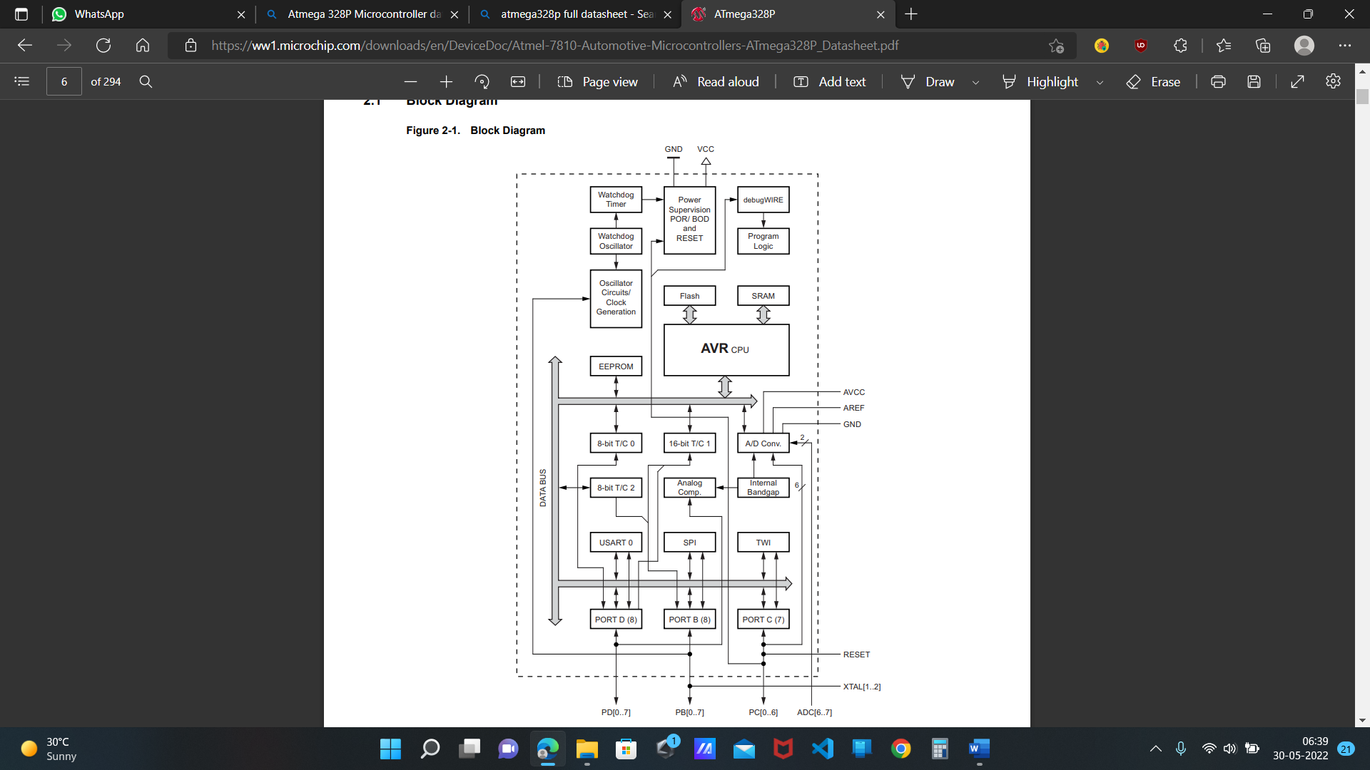

**11.2 16X2 LCD Display**

**16×2 LCD** is named so because; it has 16 Columns and 2 Rows. There are a lot of combinations available like, 8×1, 8×2, 10×2, 16×1, etc. But the most used one is the 16*2 LCD, hence we are using it here.

All the above mentioned LCD display will have 16 Pins and the programming approach is also the same and hence the choice is left to you. Below is the **Pinout and Pin Description of 16x2 LCD Module:**

|  |  |  |  |  |  |
| --- | --- | --- | --- | --- | --- |
| **Sr. No** | **Pin No.** | **Pin Name** | **Pin Type** | **Pin Description** | **Pin Connection** |
| 1 | Pin 1 | Ground | Source Pin | This is a ground pin of LCD | Connected to the ground of the MCU/ Power source |
| 2 | Pin 2 | VCC | Source Pin | This is the supply voltage pin of LCD | Connected to the supply pin of Power source |
| 3 | Pin 3 | V0/VEE | Control Pin | Adjusts the contrast of the LCD. | Connected to a variable POT that can source 0-5V |
| 4 | Pin 4 | Register Select | Control Pin | Toggles between Command/Data Register | Connected to a MCU pin and gets either 0 or 1.  0 -> Command Mode  1-> Data Mode |
| 5 | Pin 5 | Read/Write | Control Pin | Toggles the LCD between Read/Write Operation | Connected to a MCU pin and gets either 0 or 1.  0 -> Write Operation  1-> Read Operation |
| 6 | Pin 6 | Enable | Control Pin | Must be held high to perform Read/Write Operation | Connected to MCU and always held high. |
| 7 | Pin 7-14 | Data Bits (0-7) | Data/Command Pin | Pins used to send Command or data to the LCD. | In 4-Wire Mode  Only 4 pins (0-3) is connected to MCU  In 8-Wire Mode  All 8 pins(0-7) are connected to MCU |
| 8 | Pin 15 | LED Positive | LED Pin | Normal LED like operation to illuminate the LCD | Connected to +5V |
| 9 | Pin 16 | LED Negative | LED Pin | Normal LED like operation to illuminate the LCD connected with GND. | Connected to ground |

**11.3 IR sensor**

### **IR Sensor Module Features**

* 5VDC Operating voltage
* I/O pins are 5V and 3.3V compliant
* Range: Up to 20cm
* Adjustable Sensing range
* Built-in Ambient Light Sensor
* 20mA supply current
* Mounting hole

### **IR Sensor Module Pinout Configuration**

|  |  |
| --- | --- |
| **Pin Name** | **Description** |
| VCC | Power Supply Input |
| GND | Power Supply Ground |
| OUT | Active High Output |

### **Brief about IR Sensor Module**

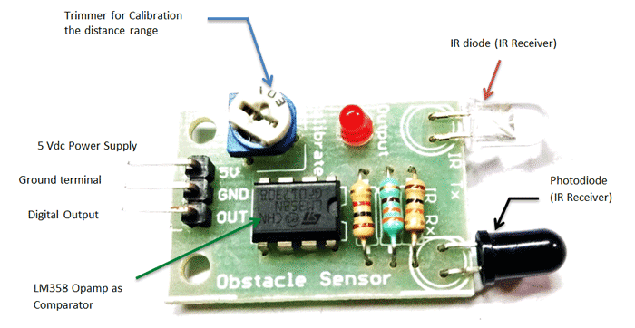

Fig 1.12 Picture of IR Sensor

The IR sensor module consists mainly of the IR Transmitter and Receiver, Op-amp, Variable Resistor (Trimmer pot), output LED along with few resistors.

**IR LED Transmitter**

IR LED emits light, in the range of Infrared frequency. IR light is invisible to us as its wavelength (700nm – 1mm) is much higher than the visible light range. IR LEDs have light emitting angle of approx. 20-60 degree and range of approx. few centimeters to several feets, it depends upon the type of IR transmitter and the manufacturer. Some transmitters have the range in kilometers. IR LED white or transparent in colour, so it can give out amount of maximum light.

**Photodiode Receiver**

Photodoide acts as the IR receiver as its conducts when light falls on it. Photodiode is a semiconductor which has a P-N junction, operated in Reverse Bias, means it start conducting the current in reverse direction when Light falls on it, and the amount of current flow is proportional to the amount of Light. This property makes it useful for IR detection. Photodiode looks like a LED, with a black colour coating on its outer side, Black colour absorbs the highest amount of light.

**LM358 Opamp**

LM358 is an Operational Amplifier (Op-Amp) is used as voltage comparator in the IR sensor. the comparator will compare the threshold voltage set using the preset (pin2) and the photodiode’s series resistor voltage (pin3).

Photodiode’s series resistor voltage drop > Threshold voltage = Opamp output is High

Photodiode’s series resistor voltage drop < Threshold voltage = Opamp output is Low

When Opamp's output is **high** the LED at the Opamp output terminal **turns ON** (Indicating the detection of Object).

**Variable Resistor**

The variable resistor used here is a preset. It is used to calibrate the distance range  at which object should be detected.

**11.4 Ultrasonic sensor**

### **HC-SR04 Sensor Features**

* Operating voltage: +5V
* Theoretical  Measuring Distance: 2cm to 450cm
* Practical Measuring Distance: 2cm to 80cm
* Accuracy: 3mm
* Measuring angle covered: <15°
* Operating Current: <15mA
* Operating Frequency: 40Hz

### **Ultrasonic Sensor - Working**

As shown above the **HC-SR04 Ultrasonic (US) sensor** is a 4 pin module, whose pin names are Vcc, Trigger, Echo and Ground respectively. This sensor is a very popular sensor used in many applications where measuring distance or sensing objects are required. The module has two eyes like projects in the front which forms the Ultrasonic transmitter and Receiver. The sensor works with the simple high school formula that

**Distance = Speed × Time**

The Ultrasonic transmitter transmits an ultrasonic wave, this wave travels in air and when it gets objected by any material it gets reflected back toward the sensor this reflected wave is observed by the Ultrasonic receiver module as shown in the picture below

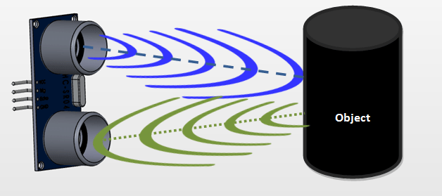

Fig. 1.13 Ultrasonic Sensor

Now, to calculate the distance using the above formulae, we should know the Speed and time. Since we are using the Ultrasonic wave we know the universal speed of US wave at room conditions which is 330m/s. The circuitry inbuilt on the module will calculate the time taken for the US wave to come back and turns on the echo pin high for that same particular amount of time, this way we can also know the time taken. Now simply calculate the distance using a microcontroller or microprocessor.

### **How to use the HC-SR04 Ultrasonic Sensor**

**distance sensor** is commonly used with both microcontroller and microprocessor platforms like Arduino, ARM, PIC, Raspberry Pie etc. The following guide is universally since it has to be followed irrespective of the type of computational device used.

  Power the Sensor using a regulated +5V through the Vcc ad Ground pins of the sensor. The current consumed by the sensor is less than 15mA and hence can be directly powered by the on board 5V pins (If available). The Trigger and the Echo pins are both I/O pins and hence they can be connected to I/O pins of the microcontroller. To start the measurement, the trigger pin has to be made high for 10uS and then turned off. This action will trigger an ultrasonic wave at frequency of 40Hz from the transmitter and the receiver will wait for the wave to return. Once the wave is returned after it getting reflected by any object the Echo pin goes high for a particular amount of time which will be equal to the time taken for the wave to return back to the sensor.

The amount of time during which the Echo pin stays high is measured by the MCU/MPU as it gives the information about the time taken for the wave to return back to the Sensor. Using this information the distance is measured as explained in the above heading.

### **Applications**

* Used to avoid and detect obstacles with robots like biped robot, obstacle avoider robot, path finding robot etc.
* Used to measure the distance within a wide range of 2cm to 400cm
* Can be used to map the objects surrounding the sensor by rotating it
* Depth of certain places like wells, pits etc can be measured since the waves can penetrate through water

**11.5 Servo Motor**

The **MG996R is a metal gear servo motor**with a maximum stall torque of 11 kg/cm. Like other RC servos the motor rotates from 0 to 180 degree based on the duty cycle of the PWM wave supplied to its signal pin.

### **Wire Configuration**

|  |  |  |
| --- | --- | --- |
| **Wire Number** | **Wire Colour** | **Description** |
| 1 | Brown | Ground wire connected to the ground of system |
| 2 | Red | Powers the motor typically +5V is used |
| 3 | Orange | PWM signal is given in through this wire to drive the motor |

### **MG996R Servo Motor Features**

* Operating Voltage is +5V typically
* Current: 2.5A (6V)
* Stall Torque: 9.4 kg/cm (at 4.8V)
* Maximum Stall Torque: 11 kg/cm (6V)
* Operating speed is 0.17 s/60°
* Gear Type: Metal
* Rotation : 0°-180°
* Weight of motor : 55gm
* Package includes gear horns and screws

**11.6 Buzzer**

### **Buzzer Pin Configuration**

|  |  |  |
| --- | --- | --- |
| **Pin Number** | **Pin Name** | **Description** |
| 1 | Positive | Identified by (+) symbol or longer terminal lead. Can be powered by 6V DC |
| 2 | Negative | Identified by short terminal lead. Typically connected to the ground of the circuit |

### **Buzzer Features and Specifications**

* Rated Voltage: 6V DC
* Operating Voltage: 4-8V DC
* Rated current: <30mA
* Sound Type: Continuous Beep
* Resonant Frequency: ~2300 Hz
* Small and neat sealed package
* Breadboard and Perf board friendly

### **Equivalents for Passive Buzzer**

Piezo Electric buzzer, Speaker , Active Passive Buzzer with Module

### **How to use a Buzzer**

A **buzzer**is a small yet efficient component to add sound features to our project/system. It is very small and compact 2-pin structure hence can be easily used on beardboard, Perf Board and even on PCBs which makes this a widely used component in most electronic applications.

There are two types of buzzers that are commonly available. The one shown here is a simple buzzer which when powered will make a Continuous Beeeeeeppp.... sound, the other type is called a readymade buzzer which will look bulkier than this and will produce a Beep. Beep. Beep. Sound due to the internal oscillating circuit present inside it. But, the one shown here is most widely used because it can be customised with help of other circuits to fit easily in our application.

This buzzer can be used by simply powering it using a DC power supply ranging from 4V to 9V. A simple 9V battery can also be used, but it is recommended to use a regulated +5V or +6V DC supply. The buzzer is normally associated with a switching circuit to turn ON or turn OFF the buzzer at required time and require interval.

### **Applications of Buzzer**

* Alarming Circuits, where the user has to be alarmed about something
* Communication equipments
* Automobile electronics
* Portable equipments, due to its compact size